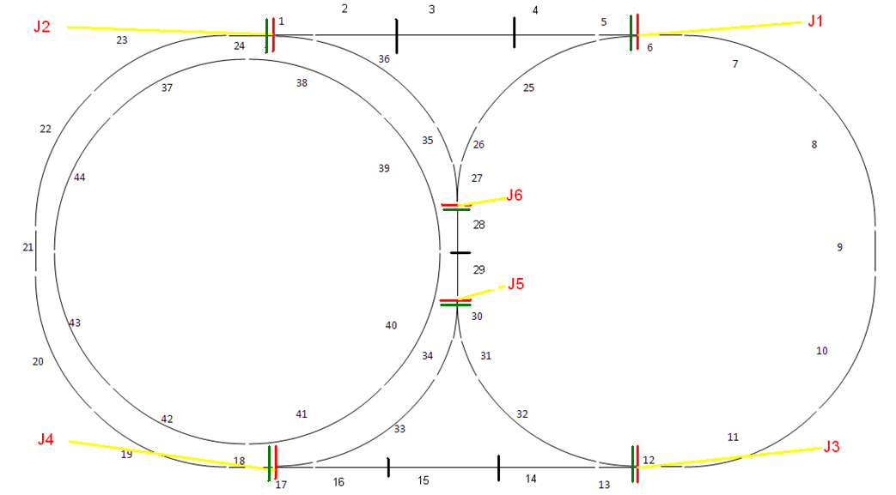

The Collision Avoidance System will attach 2 locks to each junction. The reason behind having 2 locks on the junction is because one lock on the junction is always locked by the train which is approaching that junction and the other lock is attached to the junction so that the same feature is provided to the train coming from the other side.

To understand the logic behind attaching 2 locks on the junction, let’s consider for a moment that the junction has just one lock on them. Therefore when a train approaches a junction, it locks it to avoid any train from coming in from the other side. This solves the problem of avoiding a train from entering the section however the CAS will even stop a train which is running behind the train which has locked the junction, because the CAS will encounter a lock on the junction. Even though it is safe for this train to run behind the train moving ahead of it, the CAS will stop the train. Therefore to avoid such a situation the CAS is incorporated with 2 locks on the junction.

Other reason for attaching 2 locks at the junction is, consider that a train has locked a junction ‘J3’ as it is moving towards it. Locking j3 will not ensure that the train from the opposite side does not enter the junction J1 as the junction J3 is locked and not J1 ... and now this train will enter the sections 12 11 10 as it just locks the junction and does not verify if there is another train coming from the opposite side

To explain the process of locking junction, let us consider the 2 locks on the junction to be of colour ‘Red’ and ‘Green’ (colours are given to the locks to make it easier for the reader to understand). For understanding purpose, suppose, the current location of a train is section 15 and it is moving towards the section 14, 13 (i.e. it is approaching junction ‘J3’). As the train reaches the section 14 which is a ‘Junction Section’ (A junction section is a section located 2 sections before the approaching junction so that the train can be stopped in time just in case the junction is locked) the CSA verifies if the red lock on the junction which gives permission to the train to enter the junction ‘J3’ is locked (the green lock is already locked by this train itself). If the red lock is locked, the train is not allowed to enter into the section 12 as this means that another train is approaching the junction from the other side and allowing this train to enter will cause head – on collision or a dead lock however if the red lock on the junction is unlocked then lock the green lock on the junction ‘J1’ on the other side so that no train can enter into the section 6 for the same safety reasons. After the train has passed 2 sections i.e. section 14 and 13 in this case, release the (green) lock on junction ‘J3’. The process continues and by doing this there will be no situation where in trains will be in a dead lock state.

**5.1.5 The process of locking the junction**

When the train is moving in increasing order of section it locks the green lock and verifies the red lock to enter the junction and when the train is moving in the decreasing order of section it locks the red lock and verifies if green lock is locked to enter the junction. When the train occupies a section say from 17 to 33 as shown in the figure it verifies if the section entered is odd or even and accordingly locks the junction. When it is odd it locks the red lock and when the section is even it lock the green lock and verifies red lock.